Solubility Lab Worksheet
In this lab, you will test the solubility of different substances in three different liquids to understand their properties. This information will help you decide what liquid should be used to separate the spicy chemical in hot peppers.
Warm-up
Use the solubility article from yesterday to define the terms.
Solubility
Dissolve
Like-Dissolves-Like
Polar
Non-Polar

Step 1 - Group Roles
Decide which member of your team will fulfill each role. There are 4 different research positions: Team Captain, Reporter, Technician, Data Analyst. You must have at least one member for each role.
Write your specific role and what you’re expected to do during this lab
Role
Expectations

Step 2 – Live Test
Watch as James tastes different liquids that have had chili peppers soak in them for an hour.
Record what you notice and wonder
I notice. . . | I wonder. . .

Step 3 – Testing Solubilities
In this portion of the lab, you’ll be hypothesizing what solvents dissolve which solutes based on their molecular structure.
Solvents | Solutes
Water  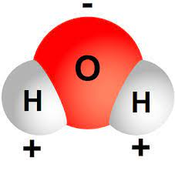 | Salt
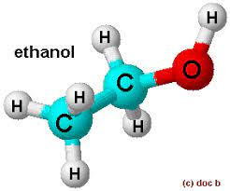 | 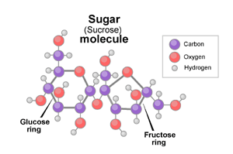
Vegetable Oil  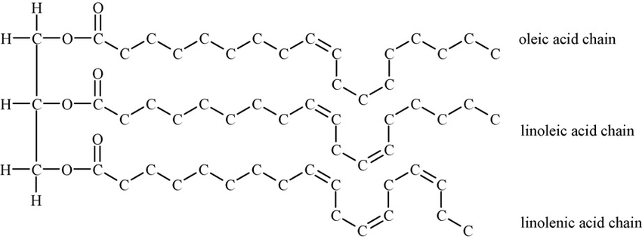 | Coconut Oil  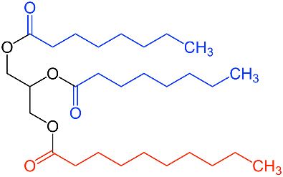
Water
What solutes do you and your team believe will dissolve in water? Write your hypotheses below and provide a brief explanation why.
Solute | Soluble? (Yes/No) | Explanation
Salt
Sugar
Coconut oil

When your team has completed making their hypotheses, your team captain can collect the following materials:
- 1 plastic cup (water)
- Salt
- Sugar
- Coconut oil
Mix one solute with water and record your results. Pour the water in the sink and repeat with the other solutes.
Solute | Result
Salt
Sugar
Coconut Oil

Ethanol
What solutes do you and your team believe will dissolve in ethanol? Write your hypotheses below and provide a brief explanation why.
Solute | Soluble? (Yes/No) | Explanation
Salt
Sugar
Coconut oil

When your team has completed making their hypotheses, your team captain can collect the following materials:
- 1 plastic cup (ethanol)
- Salt
- Sugar
- Coconut oil
Mix one solute with water and record your results. Pour the water in the sink and repeat with the other solutes.
Solute | Result
Salt
Sugar
Coconut Oil
Vegetable Oil
What solutes do you and your team believe will dissolve in vegetable oil? Write your hypotheses below and provide a brief explanation why.
Solute | Soluble? (Yes/No) | Explanation
Salt
Sugar
Coconut oil

When your team has completed making their hypotheses, your team captain can collect the following materials:
- 1 plastic cup (vegetable oil)
- Salt
- Sugar
- Coconut oil
Mix one solute with water and record your results. Pour the water in the sink and repeat with the other solutes.
Solute | Result
Salt
Sugar
Coconut Oil
Step 4 – Discuss
Can you think which solutes are polar are not based on how you observed them interact with their solvents?

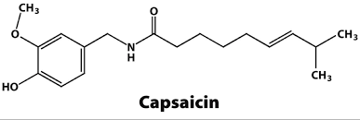
This is capsaicin, the molecule responsible for making chilis spicy. Can you hypothesize which solvent we used today would be good at washing it off of chili peppers?

